3.1) Design a web page using CSS (Cascading Style Sheets) which includes the
following:
3.1.1) Use different font, styles: In the style definition you define how each
selector should work (font, color etc). Then, in the body of your pages, you refer to
these selectors to activate the styles.
html>
<head>
<title>Usage of differnt fonts, colors </title>
<link rel="Stylesheet"type="text/css"href="in.css"/>
</head>
<body style="background-color:powderblue;">
<h1>This is the Header H1 </h1>
<h2>This is the Header H2 </h2>
<h3>This is the Header H3 </h3>
<p>This is a Paragraph </p>
</body>
</html>

HTML:
h1
{
color:indigo;
font-family:Trebuchet MS;font-size:18t;
text-decoration:underline;
}
h2
{
color:coral;
font-family:caSteller;font-size:20pt;
text-decoration:underline;
}
h3
{
color:greenyellow;
font-family:Arial Black;font-fize:20pt;
text-decoration:blink;
}
p
{
color:magneta;
font-family:fantasy;size=15pt;
font-style:italic;
}
OUTPUT:
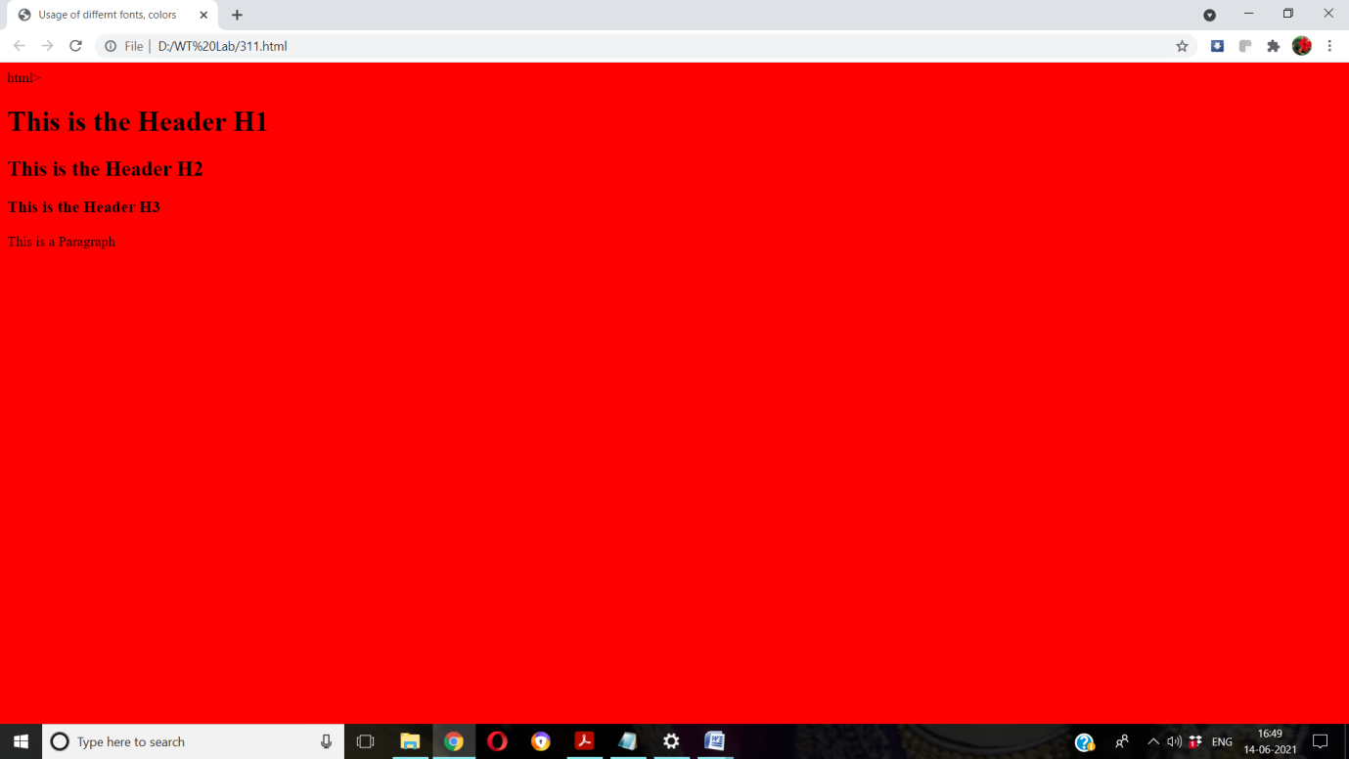

3.1.2) Set a background image for the web page and control the repetition of the
image with the background-repeat property.
<html>
<head>
<title> Background Image </title>
<style type="text/css">
body
{
background-image:url('friends.jpg');
background-repeat:no-repeat;
}
</style>
</head>
<body bgcolor="azure">
<body text="black">
<h1> Life is better with Friends </h1>
</body>
</html>

Output:
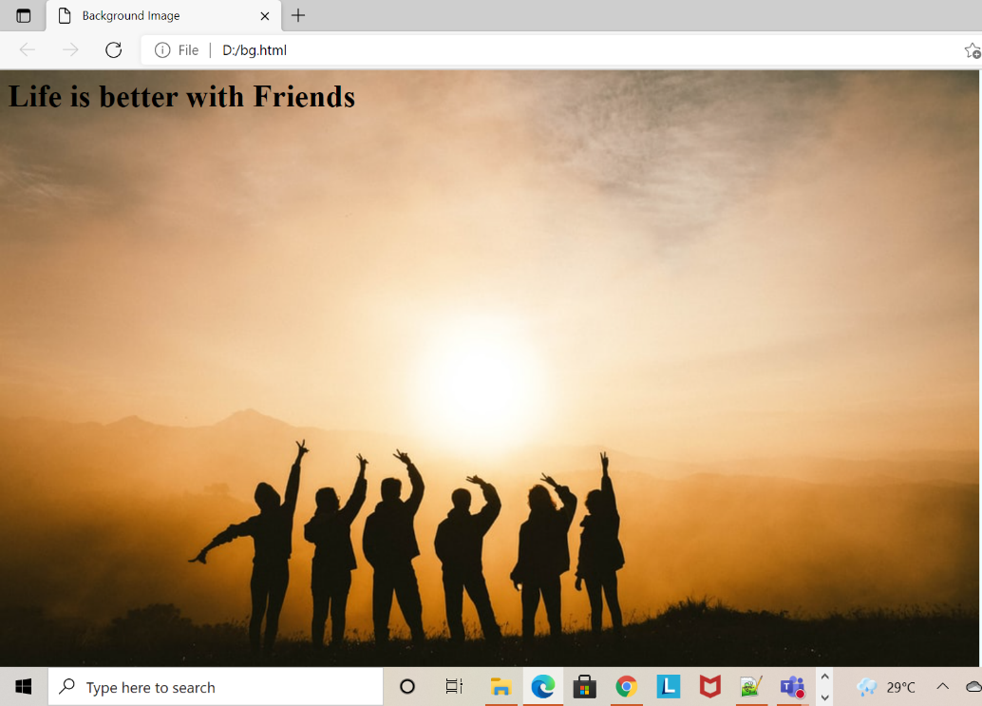
3.1.3) Define styles for link as visited, active, hover & link.

<html>
<head>
<title> CSS Webpage </title>
<style type="text/css">
body
{
background-image:url('plain.jpg');
background-repeat:no-repeat;
background-size:cover;
}
p
{
color:navy;
font-size:20pt;
font-family:coral;
background-image:url('friends.jpg');
}
a:link{font-size:20pt;background-color:white;}
a:hover{font-size:20pt;backgroud-color:pink;cursor:crosshair;}
a:active{font-size:20pt;background-color:cyan;cursor:help;}
a:visted{font-size:20pt;background-color:tan;}
</style>
</head>
<body>
<br>
<p>
Web technology refers to the means by which computers communicate with each other using markup languages and multimedia packages.
It gives us a way to interact with hosted information, like websites.
Web technology involves the use of hypertext markup language (HTML) and cascading style sheets (CSS).
</p>
<a href="link.html"><center>Register</center></a>
<br>
</body>
</html>

Output:
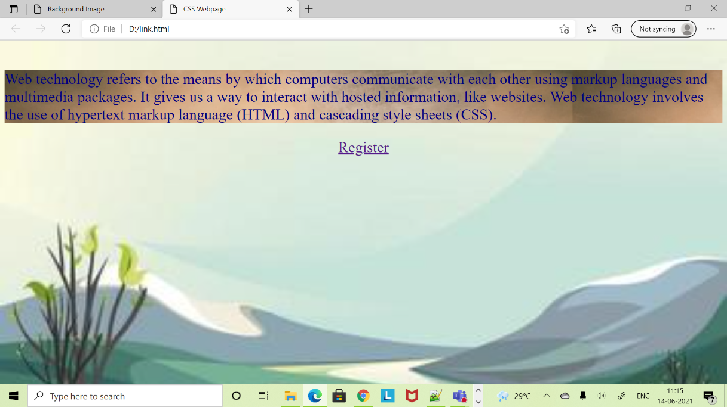

3.2) Write a JavaScript that takes a number from one text field in the range of 0-999 and display it in other text field in words. If the number is out of range, it should show “out of range” and if it is not a number, it should show “not a number” message in the result box.
<script language="javascript">
function convert_number_to_words(number)
{
hyphen='-';
conjunction='and';
separator='.';
dictionary={0:'zero',1:'one',2:'two',3:'three',4:'four',5:'five',6:'six',7:'seven',8:'eight',
9:'nine',10:'ten',11:'eleven',12:'twelve',13:'thirteen',14:'fourteen',15:'fifteen',16:'sixteen',
17:'seventeen',18:'eighteen',19:'nineteen',20:'twenty',30:'thirty',40:'fourty',50:'fifty',
60:'sixty',70:'seventy',80:'eighty',90:'ninety',100:'hundred',};
if(number<0 || number>999)
{
alert("enter a number range between 0 and 999");
return "";
}
switch(true)
{
case(number<21):
string=dictionary[number];
break;
case(number<100):
tens=parseInt(number/10)*10;
units=number%10;
string=dictionary[tens];
if(units){
string+=hyphen+dictionary[units];
}
break;
case(number<1000):
hundreds=parseInt(number/100);
remainder=number%100;
string=dictionary[hundreds]+ ' ' +dictionary[100];
if(remainder){
string+=conjunction+convert_number_to_words(remainder);
}
break;
default:
break;
}
return string;
}
a=prompt("Enter a number");
num=parseInt(a);
document.write(convert_number_to_words(num));
</script>
OUTPUT:
